11.1.7 Editors - Compositor Editor - Header - Add Menu - Output
Add menu - Output 2
Composite 2
Inputs 2
Image 2
Alpha 2
Z 2
Properties 2
Use Alpha 2
File Output 2
Inputs 2
Image 2
Properties 3
Base Path 3
File Format label 3
Levels 3
Inputs 3
Image 3
Properties 3
Channel 3
Outputs 3
Mean 4
Std Dev (Standard deviation) 4
Split Viewer 4
Inputs 4
Image 4
Image 4
Properties 4
Axis 4
Factor 4
Viewer 5
Input 5
Image 5
Alpha 5
Z 5
Properties 5
Use Alpha 5

Add menu - Output
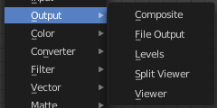
Here you will find nodes to output the result.

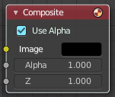
Composite
The Composite node is where the actual output from the Compositor is connected to the renderer. This node is updated after each render, but also reflects changes in the node tree (provided at least one finished input node is connected).

Inputs
Connecting a node to the Composite node will output the result of the prior tree of that node to the Compositor.

Image
RGB image. The default is black, so leaving this node unconnected will result in a blank image.

Alpha
Alpha channel.

Z
Z depth.

Properties

Use Alpha
Used alpha channel, colors are treated alpha premultiplied. If disabled, alpha channel gets set to 1, and colors are treated alpha straight, i.e. color channels does not change.
Note that if multiple Composite nodes are added, only the active one will be used.

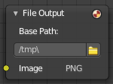
File Output
This node writes out an image as part of a frame set sequence. This happens for each specified frame range and specified to the entered filename.
This node can be used as a way to automatically save the image after a render; In addition, since this node can be hooked in anywhere in the node tree, it can also save intermediate images automatically.

Inputs

Image
The image(s) will be saved on rendering, writing to the current frame. An entire sequence of images will be saved, when an animation is rendered.
Note. To support subsequent arrangement and layering of images, the node can supply a Z-depth map. However, please note that only the OpenEXR image formats save the Z information.

Properties

Base Path
Unlike the render output file path, this node uses a base directory and an image name, by default the output path is composed of: {base path}/{file name}{frame number}.{extension}.
Besides being split into two settings, in all other respects, this setting is treated the same as the render output path.

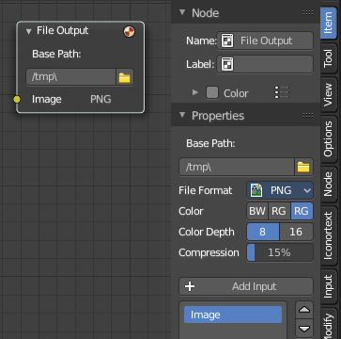
File Format label
Shows the selected File Format.
You can find further export options in the sidebar in the Item tab in the Properties panel.

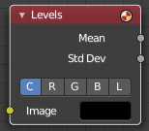
Levels
The Levels Node read the inputs color channels and outputs analytical values.

Inputs

Image
The image input.

Properties

Channel
The channels. C (Combined RGB), R (Red), G (Green), B (Blue), L (Luminance)

Outputs
1D values based on the levels of an image.

Mean
The mean is the average value of all image pixels in specified channel (combined, red, green, blue, luminance). It tells you how dark or bright the image is and can be used as such for setups that depend on how is input “bright” or “dark”.

Std Dev (Standard deviation)
How much those pixel values differ from the mean. A low standard deviation indicates that the pixel values tend to be very close to the mean. A high standard deviation indicates that the values are spread out over a large range of values.
The visualization of such data is just a gray rectangle.

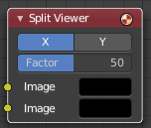
Split Viewer
The Split Viewer node takes two images and displays them side-by-side as backdrop or as a Viewer Node output. This allows you to toy around with values in direct comparison to the original. Or to compare frames with each other.
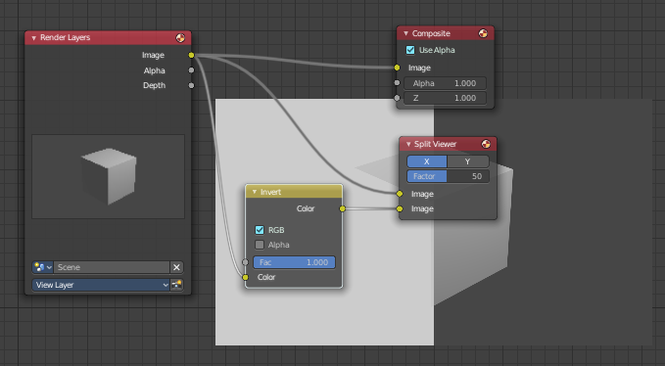

Inputs

Image
The first image input

Image
The second image input

Properties

Axis
X tiles the images horizontal. Y tiles the images vertical.

Factor
Percentage factor setting the space distribution between the two images.

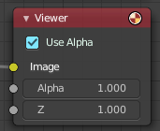
Viewer
Displays the output as a backdrop in the viewport or in the Image editor. This allows you to inspect the outputs everywhere in the node hierarchy.
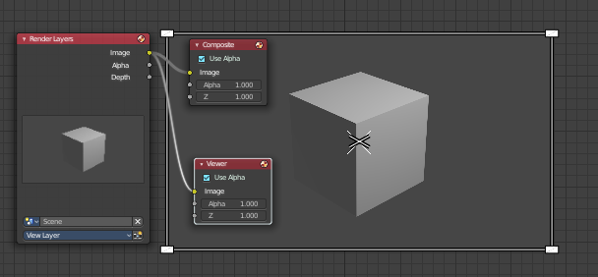
You can have more than one viewer nodes in the node editor. Just the output of the active Viewer node will be displayed. Click at a node to set it active.
When a Viewer node is selected, then the backdrop shows a widget cage that allows you to resize the backdrop image by its handlers.

Input

Image
RGB image. The default is black, so leaving this node unconnected will result in a blank image.

Alpha
Alpha channel.

Z
Z depth.

Properties

Use Alpha
Used alpha channel, colors are treated alpha premultiplied. If disabled, alpha channel gets set to 1, and colors are treated alpha straight, i.e. color channels does not change.

